 Indian School Al Wadi Al Kabir
Prelim II Examination
COMPUTER SCIENCE (Code: 083)
SET- I
CLASS : XII Max. Marks:70
Date: 25/01/2026 Time: 3 hours
General Instructions:
● This question paper contains 37 questions.
● All questions are compulsory. However, internal choices have been provided in some questions. Attempt only one of the choices in such questions
● The paper is divided into 5 Sections- A, B, C, D and E.
● Section A consists of 21 questions (1 to 21). Each question carries 1 Mark.
● Section B consists of 7 questions (22 to 28). Each question carries 2 Marks.
● Section C consists of 3 questions (29 to 31). Each question carries 3 Marks.
● Section D consists of 4 questions (32 to 35). Each question carries 4 Marks.
● Section E consists of 2 questions (36 to 37). Each question carries 5 Marks.
● All programming questions are to be answered using Python Language only.
● In case of MCQ, text of the correct answer should also be written.

Q. No. | Section-A (21 x 1 = 21 Marks) | Marks
1. | State True or False:  In a Python program, if a break statement is given in a nested loop, it brings the control out of that loop only, in which it is declared. | 1
2. | What will be the output of the following python statement?  S =[10,15,20,25]  S=S+30  print(S)  - [10,15,20,25,30]  - [40,45,50,55]  - [10,15,20,25,[30]]  - Error | 1
3. | Consider the given expression:  print(30>31 and 9>16 or 24<21 and not 75>30)  Which of the following will be the correct output of the given expression?  - True  - False  - Null  - No output | 1
4. | A table, Exam has degree 5 and cardinality 3, and another table, Marks has degree 3 and cardinality 5, what will be the degree and cardinality of the Cartesian product of Exam and Marks?  - 5,3  - 8,15  - 3,5  - 15,8 | 1
5. | Given is a Python string declaration:  exam="CBSE Examination 2025@@"  Write the output of: print(exam[::-2])  - @@5202 noitaminxE ESBC  - @52 ntoiatm BC  - CBSE Examination 2025@@  - @50 otnmx SC | 1
6. | Write the output of the following Python code:  for a in range(20, 10, -3):  print(a - 1, '%', end='') | 1
7. | What will the following expression be evaluated to in Python?  print(2**3**2//8//2**3) | 1
8. | Sreya wants to find the total commission earned by those departments where the number of employees in the department is more than 2 and write the following query:  Select department, count(commission) having count (*) > 2 group by department from techno;  But she got an error. Identify the error(s) and rewrite the query by underlining the correction(s) done. | 1
9. | What will be the output of the following Python code?  try:  num = int("win")  except SyntaxError:  print("Syntax error!")  except:  print("Some error occurred!")  - SyntaxError  - Some error occurred!  - Syntax error!  - Nothing is printed | 1
10. | What will be the output of the following Python code?  d = {1:100, 2:200}  print(d.get(3))  - 100  - 0  - None  - Error | 1
11. | Analyze the following program and select the possible output:  import random  X=random.random()  Y=random.randint(0,4)  print(int(X),”:”,Y+int(X))  - -1:0  - 1:6  - 2:4  - 0:3 | 1
12. | What will be the output of the following python code?  x = 2  def hello():  global x  x = x + 4  print(x, end='##')  hello()  print(x)  - 6##6  - 2##6  - 6##2  - Error | 1
13. | Which SQL command is used to change some values in existing rows?  - update  - insert  - alter  - order | 1
14. | Select the correct output of the code:  s1="Practice makes Perfect"  lst=s1.split(" ")  print(lst[-1])  - Practice  - Makes  - Perfect  - “Practice makes Perfect | 1
15. | Analyze the following lines of code and predict the correct output from the given options:-  S1="Better late than never"  lst=S1.split()  str_new= "@".join([lst[0].upper( ),lst[1],lst[2].capitalize()])  print(str_new)  - BETTER@LATE@THAN@NEVER  - BETTER@late@Than  - Better@Late@Than  - Better@Late@than | 1
16. | Which function is used to display the sum of values in a column named ‘Marks’?  - COUNT(Marks)  - TOTAL(Marks)  - SUM(Marks)  - ADD(Marks) | 1
17. | _____________ is a communication protocol responsible to control the transmission of data over a network.  - TCP  - SMTP  - PPP  - HTTP | 1
18. | Which of the transmission media has the highest bandwidth?  - Coaxial cable  - Twisted pair cable  - Fiber optic cable  - None of these | 1
19. | Which of the following device is used to connect network of different protocols so that they can communicate properly?  - Gateway  - Router  - Bridges  - Switch | 1
Q20 and Q21 are Assertion(A) and Reason(R) based questions. Mark the correct choice as:
- Both A and R are True and R is the correct explanation for A.
- Both A and R are True and R is not the correct explanation for A.
- A is True but R is False.
- A is False but R is True.
20. | Assertion(A):  l=[12,45,56,23,59]  l[1:4]=[43,78,52] will modify the list.  Reason(R): List slicing on the left-hand side of the assignment statement can replace the elements. | 1
21. | Assertion (A): The WHERE clause is used to filter records based on a specified condition.  Reason (R): The WHERE clause can be used only with the SELECT command. | 1
Section-B (7 x 2=14 Marks)

22. | A. Explain the difference between Mutable and immutable data types in Python with suitable example.  OR  B. How csv file is different from text file? | 2
23. | The code below is intended to count vowels in a given string and return the total number of vowels. However, it contains both syntax and logical errors. Rewrite the corrected code and underline all corrections.  def countvowel(str)  vowels = "aeiou"  count = 0  for ch in len(vowels):  if vowels[ch] in vowel:  count = count + 1  return count  print("Total vowels:" countvowel("Computer Science")) | 2
24. | A. Answer using Python built-in methods/functions only.  I. To delete the element from beginning of the list ‘MyList’  II. To insert the elements of list ‘L’ as individual elements in list ‘NewList’  OR  B. I. A string variable ‘var’ stores "Python is a programming language".  Write the Python command/s to display the number of words in the message.  II. Write the output of the code given below:  C1 = {"Color1": "Blue", "Color2": "Green"}  C2 = C1.pop('Color1')  print(C1, C2) | 2
25. | Write a function CUBE(L), where L is the list of elements passed as argument to the function. The function returns another list named New_List’ that stores the cubes of non-Zero Elements of L.  For example:  If L contains [9,4,0,11,0,6,0]  The New_List will have - [81,16,121,36] | 2
26. | Predict the output of the following code:  S="KITE"  L=[10,20,30,40]  D={}  for i in range(len(S)):  if i%2==0:  D[L.pop()] =S[i]  else:  D[L.pop()] = i+3  for K, V in D.items():  print(K, V, sep="%") | 2
27. | A. Write suitable commands to do the following in MySQL.  I. To open the database ‘Employee’.  II. To see all the available tables in the database, ‘Employee’.  OR  B. Differentiate between where and having clause in SQL with a suitable example. | 2
28. | A. Define the following terms:  I. SMTP  II. VoIP  OR  B. I. Expand the following terms: XML and URL  II. Differentiate between circuit switching and packet switching. | 2
Section-C (3 x 3 = 9 Marks)

29 | Write a function COUNTTEXT( ), which reads a text file Story.txt and displays all the words of the file whose length is more than 4 or those which start with ‘T’ or ’t’ in the form of a list.  OR  Write a function COUNTWORD( ), which counts all the words from the text file Book.txt whose second last character is ‘t’. | 3
30 | A nested list L contains the data of patients in a hospital. Each of the inner lists contains the following data of a visitor:  [P_id , DateofAdmn, P_Name, P_Gender, P_Age]  Write the following user defined functions to perform given operations on the stack named "status":  - Push_element(Patient) - To Push the name and date of admission who are in the  age range of 25 to 35.  - Pop_element() - To Pop and display the objects from the stack and also, display “Stack empty” when there are no elements in the stack.  For example: If the list Visitors contains:  [['305', "10/10/2025", “Meera”, "F”, 35],  ['306', "10/10/2025", “Leya”, "F”, 18],  ['307', "11/10/2025", “David”, "M”, 28],  ['308', "11/10/2025", “Marvin”, "M”, 32]]  The stack should contain:  [['10/11/2022', 'Meera'], ['11/11/2022', 'David'], ['11/11/2022', 'Marvin']]  The output should be:  Stack is empty | 3
31 | - Predict the output of the following Python code:  text = "PreBoard2025!"  new = ""  for i in range(len(text)):  if text[i].isalpha():  if i < len(text)-1:  new += text[i+1]  else:  print("#")  elif text[i].isdigit():  new += "@"  else:  new += "*"  print(new[::-1])  OR  - Predict the output of the following Python code:  Fruits = ["Apple", "Pear","Orange", "Pappaya"]  new = []  for x in Fruits:  if x[0] in "AEIOU":  new.insert(0, x.lower())  elif len(x) > 4:  new.append(x[::-1])  else:  new.append(x.upper())  print(new) | 3
Section-D (4 x 4 = 16 Marks)

32 | Consider the table SCHOOL as given below:  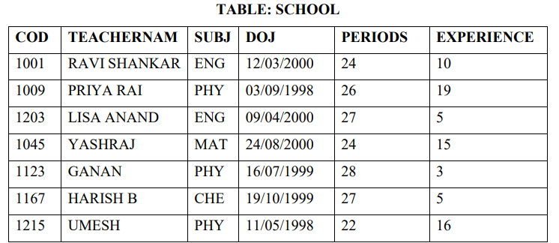  - Write the following queries:  - To display total number of periods for each subject whose total periods exceeds 52  - To display the number of subjects without repetition.  - To display the details of the teachers whose name contains letter ’H’ having Subject as English or Maths.  - To display the records of the table sorted by Teacher name in the descending order.  OR  - Predict the output of the following:  - Select * from school where Experience>12;  - Select TeacherNam from school where DOJ>’1999-12-11’;  - Select count(*) from school where SUBJ IN(‘ENG’,’CHE’,’MAT’);  - Select avg(EXPERIENCE) from school where SUBJ=’PHY’; | 4
33 | Mr. Aayush is a software engineer working at TCS. He has been assigned to develop code for product management. He has to create a CSV file named item.csv to store the details of different products.  The structure of item.csv is : [item_no, item_name, item_price, item_qty].  Mr. Aayush wants to maintain the data properly, for which he wants to write the following user-defined functions:  - AcceptItem() – to accept a record from the user and append it to the file item.csv. The column headings should also be added on top of the csv file. The number of records to be entered until the user chooses ‘Y’ / ‘Yes’.  - ItemReport() – to calculate the total sales based on item_ price*item_qty. As a Python expert, help him complete the task. | 4
34 | Mr. Mohan is managing database named ‘Test’ and needs to access certain information from the Supplier and Product tables. Help him extract the required information by writing the appropriate SQL queries as per the tasks mentioned below:  Table: SUPPLIER  Table: PRODUCT  - Display supplier name and product name of all products supplied from Delhi.  - Display supplier name and product name for products whose price lies between 50 and 250.  - To remove the Product details of those product if price is greater than 40.  - To display the cartesian product of the two tables | 4
  SID | SNAME | CITY
  S1 | GreenFarm | Delhi
  S2 | Alpha | Mumbai
  S3 | Tulips | Bangalore
  S4 | Gamma | Delhi
  S5 | Beta | Bangalore
  PID | PNAME | SID | PRICE
  P1 | Pen | S1 | 65
  P2 | Book | S2 | 100
  P3 | Pencil | S3 | 30
  P4 | Bag | S1 | 500
  P5 | File | S4 | 40
35 | Mr. Aamir wants to write a program in Python to insert the following record in the table named SPORTS in GAME database.  - spno (Sport_No)- integer  - name (Name) - string  - DOJ (Date of Join) – Date  Note the following to establish connectivity between Python and MySQL:  - Username - root  - Password - mysql  - Host - localhost  The values of fields spno, name, DOJ to be accepted from the user. Help Aamir to write the program in Python. | 4
 | Section-E (2 X 5 = 10 Marks)
36 | A file, PASSENGERS.DAT, stores the records of passengers using the following structure :  [PNR, PName, BRDSTN, DESTN, FARE]  where :  PNR – Passenger Number (string type)  PName – Passenger Name (string type)  BRDSTN – Boarding Station Name (string type)  DESTN – Destination Station Name (string type)  FARE – Fare amount for the journey (float type)  Write user defined functions in Python for the following tasks :  - Create() – to input data for passengers and write it in the binary file PASSENGERS.DAT.  - (ii) SearchDestn(D) –to read contents from the file PASSENGERS.DAT and display the details of those Passengers whose DESTN matches with the value of D.  - (iii) UpdateFare() – to increase the fare of all passengers by 5% and rewrite the updated records into the file PASSENGERS.DAT. | 5
37 | Biyani Design and Training Institute is setting up its center in Jaipur with four specialized units for Design, Media, HR and Training in separate buildings. The physical distances between these units and the number of computers to be installed in these units are given as follows. You as a network expert, have to answer the queries as raised by the administrator as given in (i) to (v).  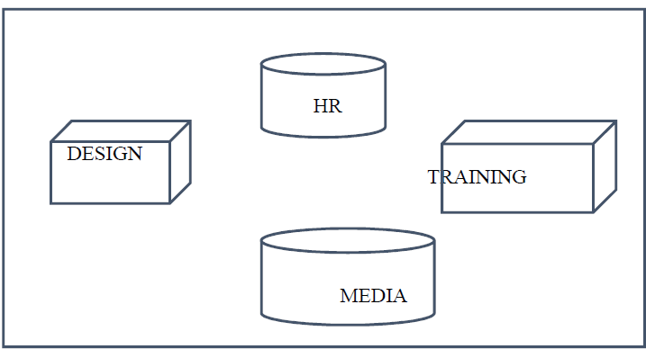  Shortest distances between various locations in meters:  Number of computers installed at various locations are as follows:  - Suggest the most suitable place (i.e., Unit/Building) to install the server of this Institute. Justify.  - Suggest an ideal layout for connecting these Unit/Building for a wired connectivity.  - Suggest the devices to be installed in each of these buildings for connecting computers installed within each of the units out of the following:  Modem, Switch, Gateway, Router  - Suggest an efficient as well as economic wired medium to be used within each unit for connecting computer systems out of the following network cable:  Co-axial Cable, Ethernet Cable, Single Pair Telephone Cable.  - The institute is planning to connect its admission office in Bangalore, which is  1960km from institute. Which type of network out of LAN, MAN or WAN will be  formed? Justify your answer. | 5
  Design Unit to Media Unit | 60
  Design Unit to HR Unit | 40
  Design Unit to Training Unit | 60
  Media Unit to Training Unit | 100
  Media Unit to HR Unit | 50
  Training Unit to HR Unit | 60
  Design Unit | 40
  Media Unit | 50
  HR Unit | 110
  Training Unit | 40

